They were both in white, and their dresses were rippling and fluttering as if they had just been blown back in after a short flight around the house



-----The Great Gatsby. Chapter 1, description of Daisy Buchanan and Jordan Baker. The two are so lightweight that they appear to be floating, the imagery suggests that the characters live restless, dissatisfied and hollow lives. They dress in white, symbol of purity, but that may be seen as ironic because of their own corruption. The tranquility of the scene is disrupted by Tom Buchanan who abruptly shuts the windows with a ‘boom’, suggesting trouble in paradise and Tom’s violent nature.

The master sat throned in his great chair upon a raised platform, with his blackboard behind him. He was looking tolerably mellow. Three rows of benches on each side and six rows in front of him were occupied by the dignitaries of the town and by the parents of the pupils. To his left, back of the rows of citizens, was a spacious temporary platform upon which were seated the scholars who were to take part in the exercises of the evening; rows of small boys, washed and dressed to an intolerable state of discomfort; rows of gawky big boys; snowbanks of girls and young ladies clad in lawn and muslin and conspicuously conscious of their bare arms, their grandmothers’ ancient trinkets, their bits of pink and blue ribbon and the flowers in their hair. All the rest of the house was filled with non-participating scholars.

老师就像皇帝一般坐在那把高大的椅子上面，他的身后就是一块黑板。老师看上去有些微醺的样子，但还过得去。他的两边各摆着三排长椅，上面坐着镇上的达官贵人，他的前面还放着六排长椅，坐着的都是学生家长。在他的左边，几排家长座位的后面临时搭起了一个大舞台，上面坐着将要参加晚上考试的考生们。一排排的小男孩被洗得干干净净，穿戴得整整齐齐，这情形让人难以忍受，令人作呕。在他们后面是一排排神情呆板愚钝的大男孩。那些小女孩和大姑娘们身穿用上等细麻软布做成的衣服，坐在那儿犹如一条洁白的雪堤。她们裸露着胳膊，头上戴着老祖母的旧首饰，系着各种粉红色或蓝色的丝带，头发里还插着鲜花，她们早已意识到自己这身打扮有多么引人注目。教室的其他地方挤满了不用参加考试的学生。

----The Adventure of Tom Sawyer

Chapter 22

With delightful emotions does the youthful mind look forward to some anticipated festivity! Imagination is busy sketching rose-tinted pictures of joy. In fancy, the voluptuous votary of fashion sees herself amid the festive throng, ‘the observed of all observers.' Her graceful form, arrayed in snowy robes, is whirling through the mazes of the joyous dance; her eye is brightest, her step is lightest in the gay assembly. “In such delicious fancies time quickly glides by, and the welcome hour arrives for her entrance into the Elysian world, of which she has had such bright dreams. How fairy-like does everything appear to her enchanted vision! Each new scene is more charming than the last. But after a while she finds that beneath this goodly exterior, all is vanity, the flattery which once charmed her soul, now grates harshly upon her ear, the ball-room has lost its charms; and with wasted heath and imbittered heart, she turns away with the conviction that earthly pleasures cannot satisfy the longings of the soul!"

年轻人们怀抱着无比愉快的心情期盼着庆典的到来。他们驰骋的想象力忙碌地描绘着玫瑰色的喜悦画卷。 奢侈逸乐的时尚弄潮儿在梦幻之中发现自己置身于欢乐的人群，成为众人瞩目的焦点。她体态优雅端庄，身穿洁白礼服，在纷杂欢舞的人群中翩翩起舞。她的双眼迸发出耀眼的光芒，在所有欢快的舞者中她的舞步最为轻盈。在这美妙的梦境中，时光飞逝如梭，梦寐以求的极乐世界终于张开双臂欢迎她的到来。在她心醉的幻想之中，所有旁物都似仙女下凡般楚楚动人！每到一处，景色都变得更加迷人。但时隔不久，她便发现在这迷人的外表之下，一切都虚华于世。曾经令她心花怒放的甜言蜜语，此刻却变得铮铮刺耳，舞会失去了它迷人的魅力。随着身心的渐渐疲乏，她转身离开了舞会，笃信这世俗的愉悦无以慰藉心灵的企求！

A large head, reddish-brown hair ruffled; between two shoulders hunched a huge hump, corresponding to the front of their chicken carina; thigh and calf, Qiniubawai, not a one posture, between his legs only knee to barely close together, from the front, like two crescent-shaped scythe, with only a knife bonding; large feet, enormous hands; Furthermore, such a deformed body, but it has a kind of hard to describe like terrible posture: energetic, vigorous and agile, extraordinary courage.  
  
一个大脑袋,红棕色头发竖起；两个肩膀之间耸着一个偌大的驼背,与其相对应的是前面鸡胸隆凸；大腿与小腿,七扭八歪,不成个架势,两腿之间只有膝盖才能勉强并拢,从正面看去,活像两把月牙形的大镰刀,只有刀把接合在一起；宽大的脚板,巨大无比的手掌；而且,这样一个畸形的身躯,却有着一种难以描状的可怕体态：精力充沛,矫健敏捷,勇气非凡。

Scarlett O'Hara was not beautiful, but men seldom realized it when caught by her charm as the Tarleton twins were. In her face were too sharply blended the delicate features of her mother, a Coast aristocrat of French descent, and the heavy ones of her florid Irish father.But it was an arresting face, pointed of chin, square of jaw.Her eyes were pale green without a touch of hazel, starred with bristly black lashes and slightly tilted at the ends.Above them, her thick black brows slanted upward, cutting a startling oblique line in her magnolia-white skin - that skin so prized by Southern women and so carefully guarded with bonnets, veils and mittens against hot Georgia suns.  
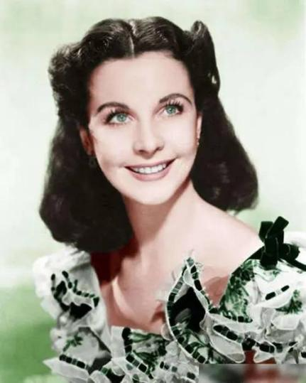

# **[Gone with the Wind](https://www.goodreads.com/book/show/18405.Gone_with_the_Wind)**  by [Margaret Mitchell](https://www.goodreads.com/author/show/11081.Margaret_Mitchell)

斯嘉丽其实长得并不漂亮，然而，男人们被她的魅力迷住时，却极少意识到这一点，塔尔顿家那一对孪生兄弟就是如此。她的脸上显然融合了她的母亲（沿海一位法兰西血统的贵族）和她的父亲（爱尔兰后裔）的特点，既标致娇柔，又红润粗犷。这张脸实在迷人，非常引人注目，尖尖的下巴，方形的下颚，双眼则呈淡绿色，一点茶褐色也没有。黑黑的睫毛圈在眼睛周围，尾部还微微有点翘，带着点欢快俏皮的模样。眼睛上方，两道墨黑的浓眉向上翘起，在她那像木兰花一样洁白的皮肤上画出两道颇为抢眼的斜线。南方的太太小姐们都非常珍视这种肤色。她们总是戴着帽子、围着面纱、戴着露指长手套，小心地呵护着自己的皮肤，以免让佐治亚州炎热的太阳光晒黑。